
Activity 2 worksheet – Navigate

Aim : Experiment with simple robot vehicle steering.

Task
- Connect cable and switch controller to robot
- Set your switch controller switches to the OFF position (see picture).
- Power-on the robot and select MODE “J1” by pressing “2A_D_A” (press switch A twice, switch D once and switch A once.)
- Now run the robot to work out the effect of the controlling switches.
- The two switches on the controller each have 3 positions which give NINE possibilities. Fill in table 1 below with the NINE possibilities using the symbols in table 2.

right switch →

left switch ↓
OFF

Table 1: Nine possible switch controller positions

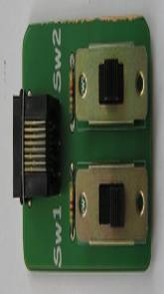
Right switch
Left switch
Front
Switch controller
OFF position
Effect | Symbol
Slow forward
Fast forward
Spin left or right at slow speed

Spin left or right at fast speed

Turns left or right

Table 2: Symbols required for filling out table 1

- Lay your robot storage box on the floor and try to steer your robot around the box. See how close you can go without hitting the box.

- In a later activity you will participate in a competition using this method of steering.

